Linear Regression : Ice Cream Revenue Prediction

1. Introduction
This report implements and explains univariate linear regression from first principles using explicit summed gradients that match the lecture notation in strict θ₀, θ₁ form. Two solution approaches are compared: batch gradient descent (with simultaneous updates) and the closed-form normal equation. The Python implementation (NumPy / pandas) is included and presented using listings for reproducibility. Following equations were used for linear regression:
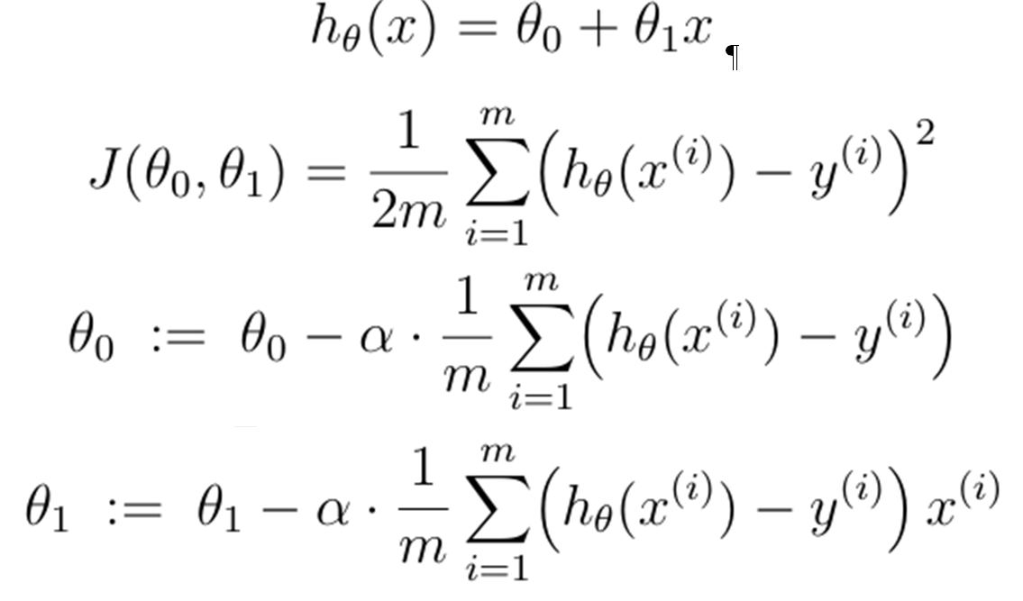
2. Problem Statement and Objectives
Problem. Predict daily revenue (y) from measured temperature (x) using univariate linear regression.
Objectives.
- Implement the hypothesis h_θ(x) = θ₀ + θ₁x.
- Implement the cost function J(θ₀, θ₁).
- Compute explicit summed gradients (first principles) and apply batch gradient descent (simultaneous updates).
- Compute closed-form solution using the normal equation for comparison.
- Produce per-example diagnostics to show terms used in the gradient sums.

3. Data and Preprocessing
- Read CSV via pandas.read_csv.
- Auto-select numeric columns if names differ.
- Remove rows with missing values.
- Set m equal to number of valid examples.
Parameters used in the baseline experiment:
- α = 0.001 (alpha)
- iterations = 1000 (iters)
- initial θ₀ = 0.0, θ₁ = 0.0

4. Code Run

(a) Per-example Diagnostic Table (Final Iteration)
Table 1 shows the per-example diagnostics computed during the final iteration of the gradient descent procedure. Each row corresponds to a training example with its temperature input (x), observed revenue (y), model prediction (h_theta(x)), residual error (h-y), and the product term (error * x) used in gradient computation. The last row reports the aggregated sums of each column, confirming that the mean gradients derived from these sums match the printed gradient values at convergence confirming the correctness of the numerical updates and that the optimization has reached a near-minimum.
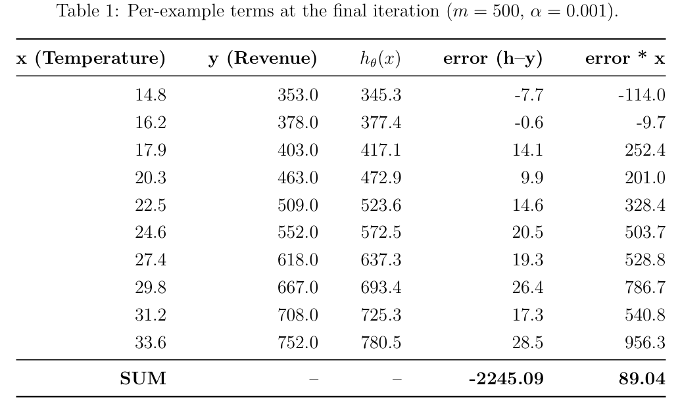

5. Results Summary
The final parameter estimates obtained from both the first-principles batch gradient descent and the closed-form normal equation are summarized in Table 2. The gradient descent method converged successfully to a low cost value after 1000 iterations, producing an interpretable linear relationship.
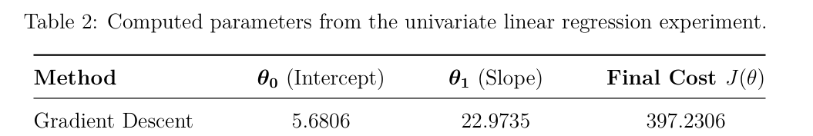

The figures below illustrate the model fit and the optimization behavior. Fig. 1 shows the training data (scatter) together with the fitted regression lines obtained from batch gradient descent and the normal equation. Fig. 2 presents the cost function plotted against iteration number to demonstrate convergence of the gradient descent optimizer. Both images were generated by the script and saved as fig_fit.png and fig_cost.png in the report folder; replace these files with new plots if you re-run the code.
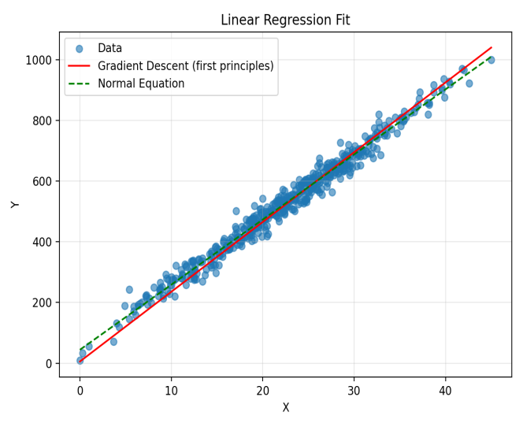  Fig.1 Training Data with Regression Lines | 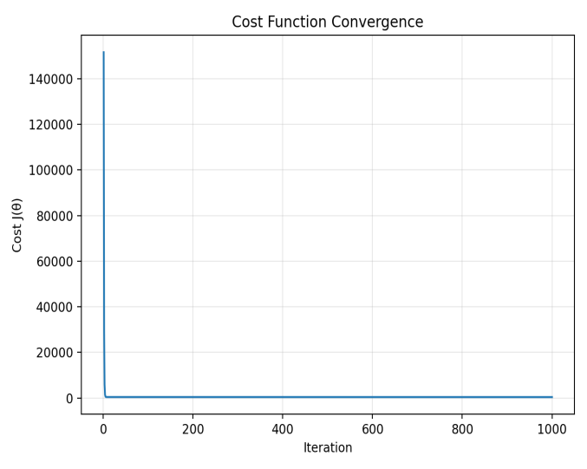  Fig.2 Cost Function Convergence

6. Discussion
The implementation exactly matches the lecture equations using explicit summed gradients for θ₀, θ₁. Batch gradient descent with a small α converges slowly but is numerically stable for this simple uni-variate dataset. The normal equation provides a closed-form solution that often gives similar slopes but can differ in intercept due to various factors (outliers, preprocessing differences, numerical precision).

7. Conclusion

The ice cream revenue data was successfully fitted with a linear regression. The parameters were found for the fitted line and the cost function converged to minimal error.

